**Final Project**

Vidhi Ashutosh Savaliya (8825500)

Thi Nguyen Ngoc Nguyen (8887532)

Conestoga College, Waterloo

Computer Programming And Analysis

Islam Mahmoud

December 10, 2023

**Description:**

Players are drawn in by the simple yet difficult gameplay of FlapMono, an exciting side-scrolling endless runner game. Players take control of an ever-moving bird-like figure against an eye-catching backdrop. The main goal is to guide the bird through a sequence of pipes that are organized vertically by tapping the spacebar to make it climb. The difficulty is in developing the timing and dexterity needed to fit through the pipe openings. Every time you play the game, you may expect a novel and unexpected experience because of its dynamic level design.

The addictive quality of FlapMono is one of its best qualities; it pushes players to keep trying to beat their previous high scores. Players compete with one another as they try to cover longer distances because the game's scoring system is based on distance covered. All skill levels may play it because to the simple controls, and those looking for a challenge will find the game satisfying due to its gradually growing difficulty. With its lively graphics, snappy controls, and upbeat soundtrack, FlapMono is a fun and interesting trip into the infinite running universe.

Additionally, FlapMono adds special features to improve the gameplay. Strategic placement of power-ups, extra items, or unique obstacles can offer variation and element of surprise to the gameplay. Furthermore, social aspects that promote healthy rivalry among players, such online leaderboards or achievements, could be incorporated. FlapMono is a popular mobile game that can be played for short periods of time or for longer periods of time because of its unique combination of simplicity, challenge, and replayability. Both casual and serious players enjoy playing it

**Diagram**

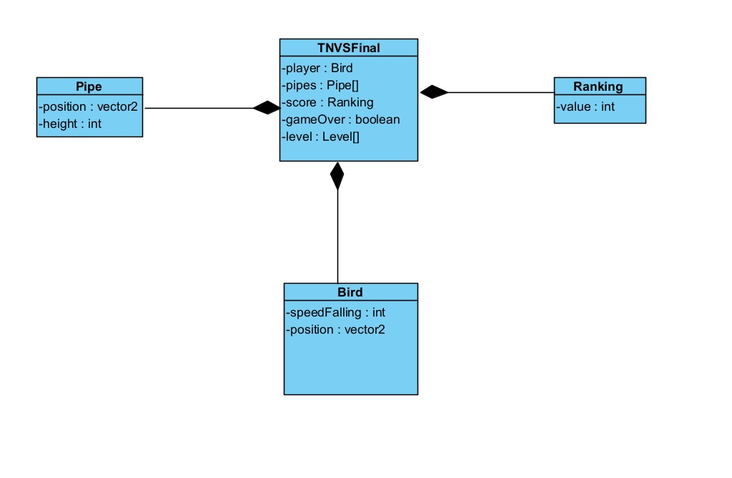

**References**

Background: <https://www.pinterest.ca/pin/24629129189169084/https://www.newgrounds.com/art/view/mixboxmixing/simple-dark-purple-background-1>

Day-Background:

<https://www.pinterest.ca/pin/24629129189169084/>

Night-Background:

<https://in.pinterest.com/pin/840343611702932043/>

Base: <https://www.kindpng.com/imgv/JJJohw_flappy-bird-ground-scratch-hd-png-download/>

Blue Bird:

<https://freepngimg.com/png/109941-logo-bird-flappy-free-transparent-image-hq>

Game Over:

https://www.seekpng.com/ima/u2q8o0r5i1o0u2t4/

Pipe:

<https://hotcore.info/act/kareff-121579.html>

Flappy-Main:

<https://blog.csdn.net/weixin_44610644/article/details/104836017>

Video:

<https://www.youtube.com/watch?v=tN8iLHRwE0w&t=14s>

<https://www.youtube.com/watch?v=m-8jDVlT7hc&t=13s>